# Shapes and Attributes

## Question: 1

Which of the following programs will correctly draw a circle with a radius of 100 at the center of the canvas?

from tkinter import *

root = Tk()

screen=Canvas(root, width = 400, height = 400)

screen.pack()

screen.create_oval(300, 100, 300, 100)

mainloop()

from tkinter import *

root = Tk()

screen=Canvas(root, width = 400, height = 400)

screen.pack()

screen.create_oval(100, 100, 300, 300)

mainloop()

from tkinter import *

root = Tk()

screen=Canvas(root, width = 400, height = 400)

screen.pack()

screen.create_oval(100)

mainloop()

from tkinter import *

root = Tk()

screen=Canvas(root, width = 400, height = 400)

screen.pack()

screen.create_oval(300, 100, 300, 100)

mainloop()

## Question: 2

What shape will be drawn when the following line of code is run?

screen.create_line(50, 50, 150, 50, 100, 100, 50, 50, fill="red")

1. 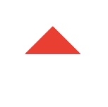
2. 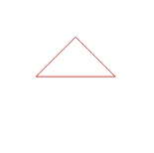
3. 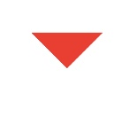
4. 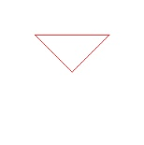

# Creating Graphics Using Variables

## Question: 1

What is the coordinate point of the center of any size canvas if the width is controlled by canvas_width and the height is controlled by canvas_height?

1. (canvas_width/2, canvas_height/2)
2. (canvas_width, canvas_height)
3. (canvas_height, canvas_width)
4. (canvas_height/2, canvas_width/2)

## Question: 2

Which command would draw a line from the center of the canvas to the bottom right corner of the canvas, no matter the dimensions?

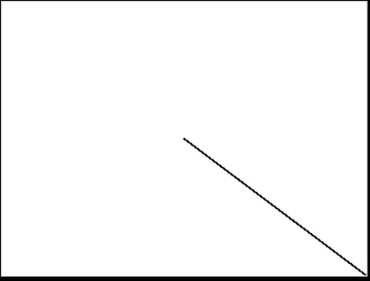

(Note: Canvas dimensions are controlled by variables canvas_width and canvas_height.)

1. screen.create_line(canvas_width/2, canvas_height/2, canvas_width, canvas_height/2)
2. screen.create_line(canvas_width, canvas_height/2, canvas_width/2, canvas_height)
3. screen.create_line(canvas_width/2, canvas_height/2)
4. screen.create_line(canvas_width/2, canvas_height/2, canvas_width, canvas_height)